Student’s Name: Kibet Brian
Admission Number: 190814
Lecturer’s Name: Mr. Talo Harrison
Course Unit: MST 8303 Penetration Testing, PT
Course Code: MST 8303
Lab – Hacking a Wireless Network Using Kali Linux
Date: August 15th, 2025

Lab – Hacking a Wireless Network Using Kali Linux
Wireless USB adapter is present under devices.
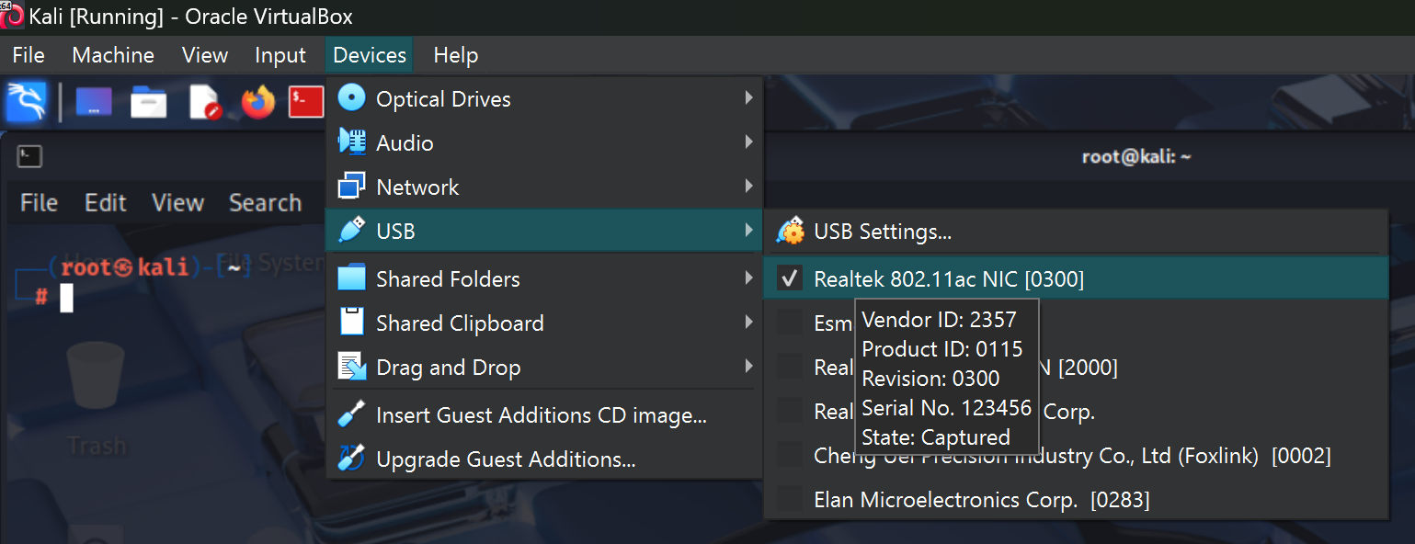

Checking for my wireless adapter. 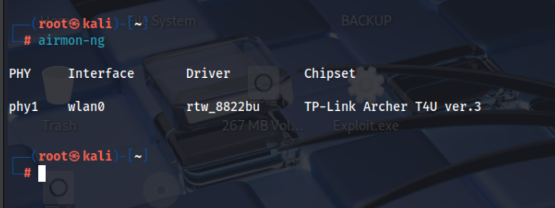

Starting my wireless adapter in monitor mode. 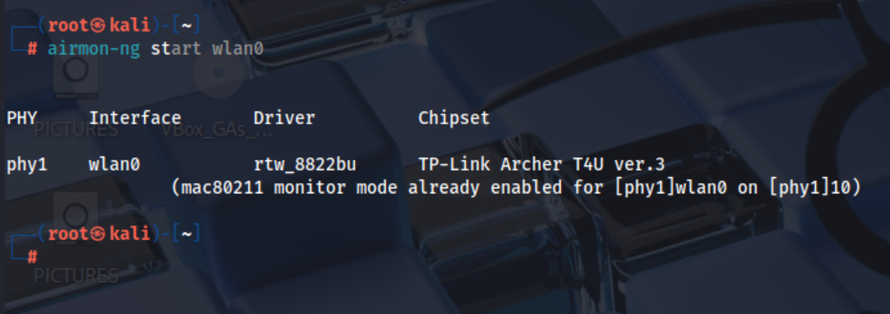

Scanning for any available wireless network traffic. 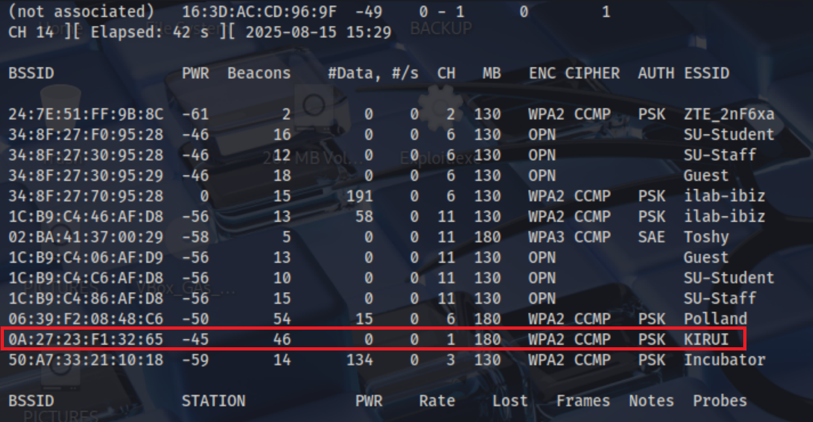

Focusing on this network.
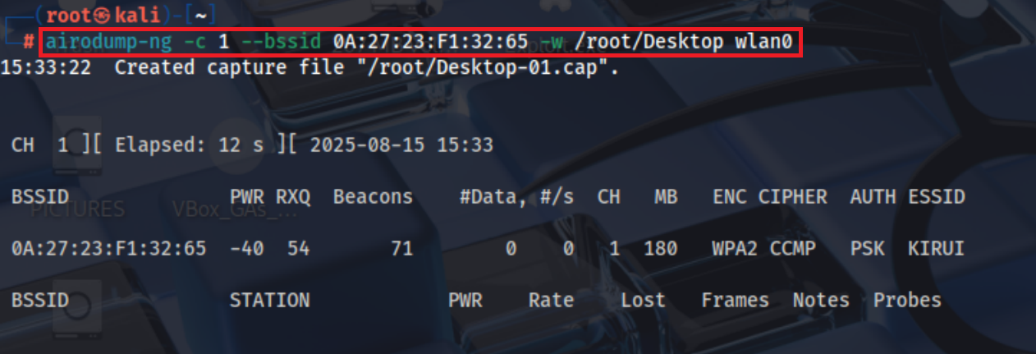

File of interest. 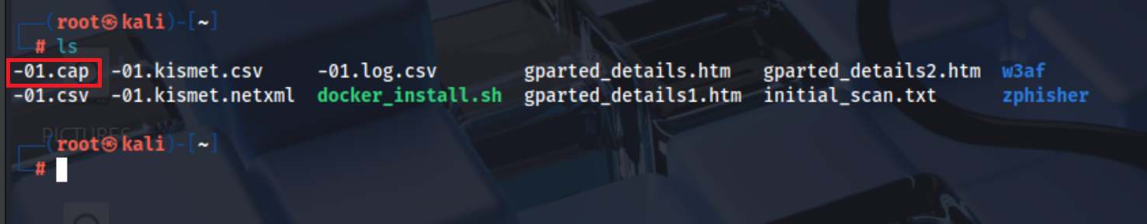

On first attempt, got a no EAPOL data was found in the file. 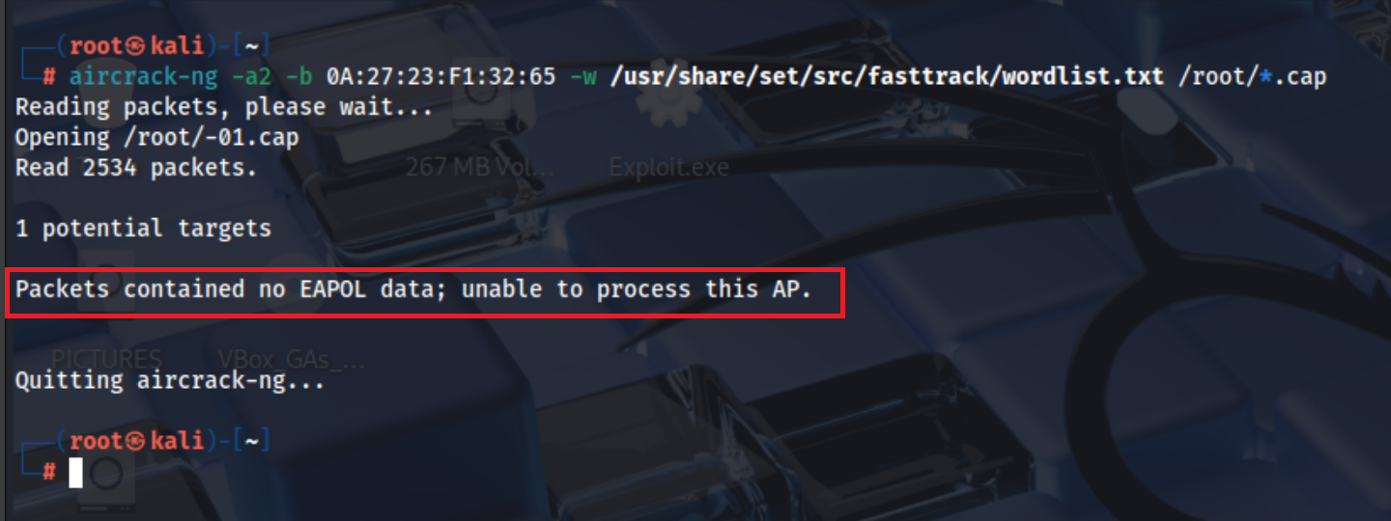

I realised that I had not added password for my access point. After adding I was able to procee and I found the key.